2nd International Symposium on Carbon Materials (2025 ISCM-2) for Energy, Environment, Sustainability, and Bio-applications (Palatino Linotype 16)

Wei-Ren Liu¹, Ying-Chih Pu², Chi-Hsien Huang³, Ting-Yu Liu^{3*} (Palatino Linotype 12 Presenter please underline; Corresponding author please mark *)
¹Department of Chemical Engineering, Chung Yuan Christian University, Taoyuan City, 320314, Taiwan (Palatino Linotype 10)
²Department of Materials Engineering, National University of Tainan, Tainan City 700301, Taiwan
²Department of Materials Engineering, Ming Chi University of Technology, New Taipei 243303, Taiwan
*Correspondence: tyliu@mail.mcut.edu.tw (T.-Y.L.) (Palatino Linotype 10)

Abstract. It is our great pleasure to welcome you to participate 2nd International Symposium on Carbon Materials (2025 ISCM-2) for Energy, Environment, Sustainability, and Bio-applications in Ming Chi University of Technology, New Taipei City, Taiwan, from Jan. 13 to Jan. 16, 2025. As the theme of “Carbon, for a better world”, we have given our all to prepare for this event. The famous plenary, keynote, and invited speeches will provide an excellent platform for sharing cutting-edge knowledge, recent research results and advanced technologies in the diverse areas of carbon materials. A special session discussing the CO₂ Reduction/Utilization/Neutralization will be included as well. Stimulating social programs have been planned to convey extensive networking chances with world-wild brilliant scholars, researchers, and young generation. Once again, welcome to 2025 ISCM-2 and New Taipei City, Taiwan. https://2025-iscm-2.conf.tw. (Palatino Linotype 11; One-Page Abstract (maximum 300 words); Format: including references and graphic abstract figure)
References (Palatino Linotype 11)
- Kuan-Syun Wang, Tsai-Yu Kuan, Yun-Chu Chen, Yu-Ju Chu, Jeng-Shiung Chen, Cheng-Cheung Chen*, Ting-Yu Liu*, Simultaneous detection of SARS-CoV-2 S1 protein by using flexible electrochemical and Raman enhancing biochip, Biosensors and Bioelectronics 249 (2024) 116021.
Graphic abstract (Palatino Linotype 11)
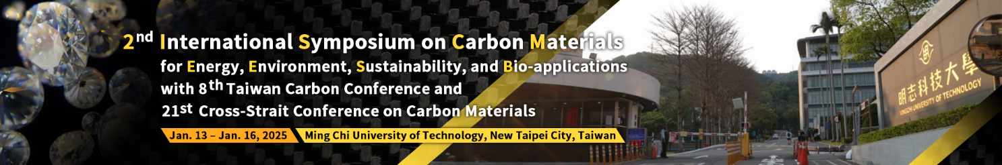

Figure 1. Schematic diagram of your research

